**Project 7 Coin Detection with OpenCV**

Name: Vivian Feng Period: 6 Date: 3/20/2023

Did you name your file l071.cpp (Lower case L, then 071)? Yes

Did you use OpenCV to detect coins? Yes

Did you test your code on terminal/gnu linux in c++11? Yes

Does your application create imageCircles.jpg file? Yes

Does your application create imageCoins.jpg file? Yes

Does your code display on the screen and in results.txt a summary of your results? Yes

What functions/methods from OpenCV did you use?

* Canny() - applies canny edge to the image
* dilate() - replaces each pixel with the maximum value in the surrounding area
* erode() - replaces each pixel with the minimum of the surrounding pixels
* convertTo() - increases the contrast in an image
* GaussianBlur() - smoothes out noise in the image
* HoughCircles() - applies Hough circles algorithm to a grayscale image
* cvRound() - convenience function that rounds a double value to an integer
* For identifying coins, first the average radius of a penny is found to establish the reference radius. Functions used for identifying pennies(which have a higher hue), isolating the pennies, and classifying coins:
  + cvtColor() - converts image from BGR to HSV color space
  + extractChannel() - isolate the saturation channel (only pennies show up brightly in the saturation channel)
  + threshold() - create a binarized image with only pennies showing
  + morphologyEx() - fill the gaps in the binary penny image using a morphological closing operation
  + bitwise_and() - mask the original saturation image to put all the pennies on a dark background, apply HoughCirles to the saturation image to find the reference penny radius to use
  + findContours(), contourArea() - used to compute the area of a coin that had high saturation. If saturation was greater than a certain value, it was classified as a penny
* imread() - used to read image
* imwrite() - write image to file
* circle() - draw circle of radius r on the image

__________________________________________________________________________________

What functions/methods from OpenCV did you experiment with but ended up not using?

createCLAHE(), CLAHE - creates an object that performs the contrast-limited Adaptive Histogram Equalization algorithm. Used in an attempt to increase the color difference between the table and the coins

blur() - replaces each pixel with the average value of its surrounding pixels

HoughCircles() - HOUGH_GRADIENT_ALT - flag introduced in newer versions of OpenCV that uses Schar derivatives instead of the Sobel Operator

bilateralFilter() - a filter that preserves edges but decreases color variation

stackFilter() - a filter that has a similar effect to the Gaussian blur on color images

cvtColor() with COLOR_BGR2Lab - convert an image to LAB colorspace, and see if that would remove coin edges within the coin

Run your code (the same code you submit) on the 3 images I provided (easy, medium, hard) then paste here the following:

* The initial image ( the one I provided), the imageg.jpg, imagef.jpg, imageCircles.jpg , imageCoins.jpg you obtained running your code, copy paste here the content of your results.txt file your code created

1. For the easy image:

Command line including all parameter values used for this image:

-f coinsEasy.jpg -ht 150 -TC 27 -mincentdist 80 -minR 80 -maxR 120 -nofilter -fg easyg.jpg -fCi easycircles.jpg -fCo easyCoins.jpg -fR easyresults.txt

-f filename

-ht high threshold for Canny Edge

-TC vote count threshold for HoughCircles()

-mincentdist minimum distance between two circle centers

-minR minimum radius for Hough Circles

-maxR maximum radius for Hough Circles

-nofilter - no arguments, flag indicates do not apply any blurs/image filters on grayscale image before performing Canny Edge

-fg name of grayscale image (default: imageg.jpg)

-fCi name of circle image (default: imageCircles.jpg)

-fCo name of coin image (default: imageCoins.jpg)

-fR name of results file (default: results.txt)

-ff name of canny edge file (default: imagef.jpg)

Initial image:

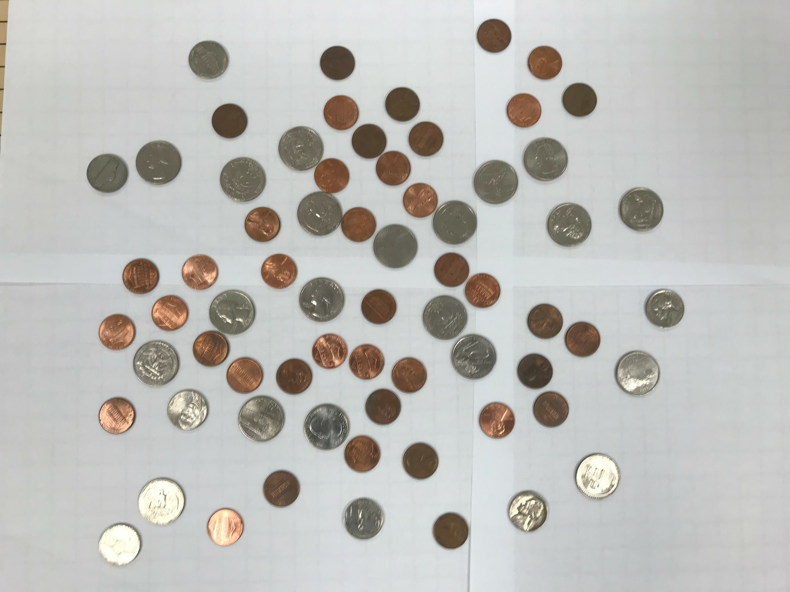

imageg.jpg:

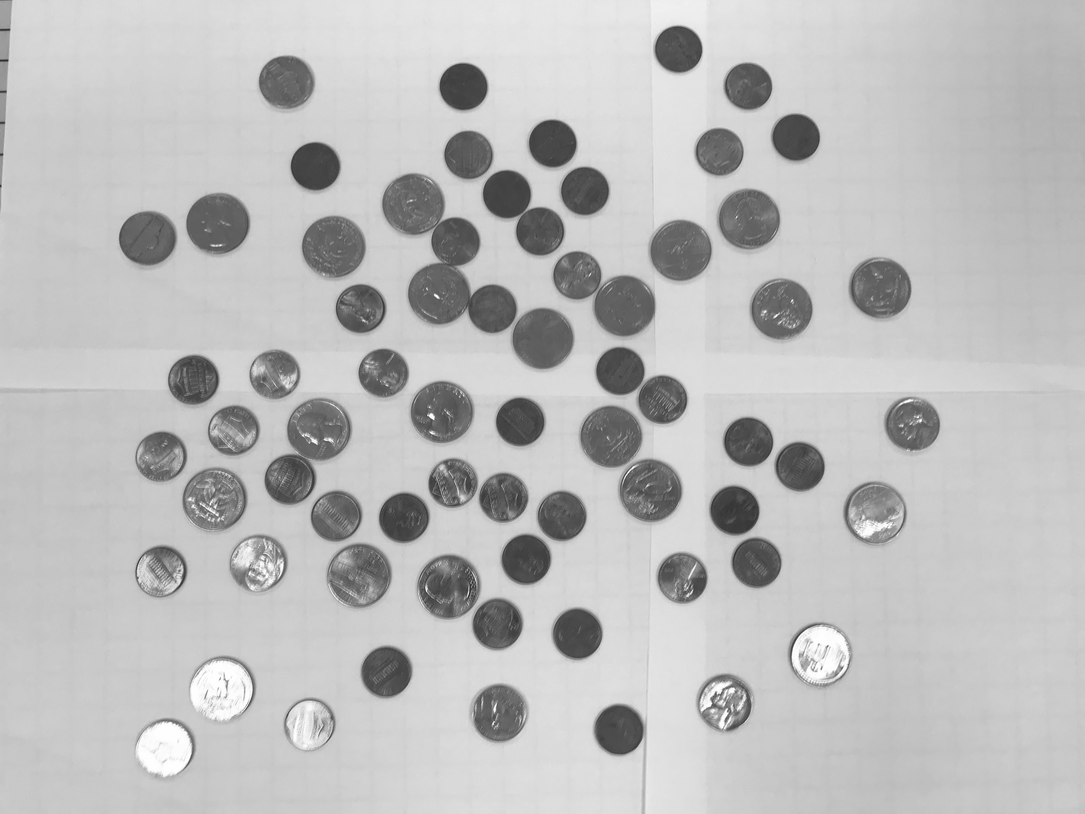

imagef.jpg

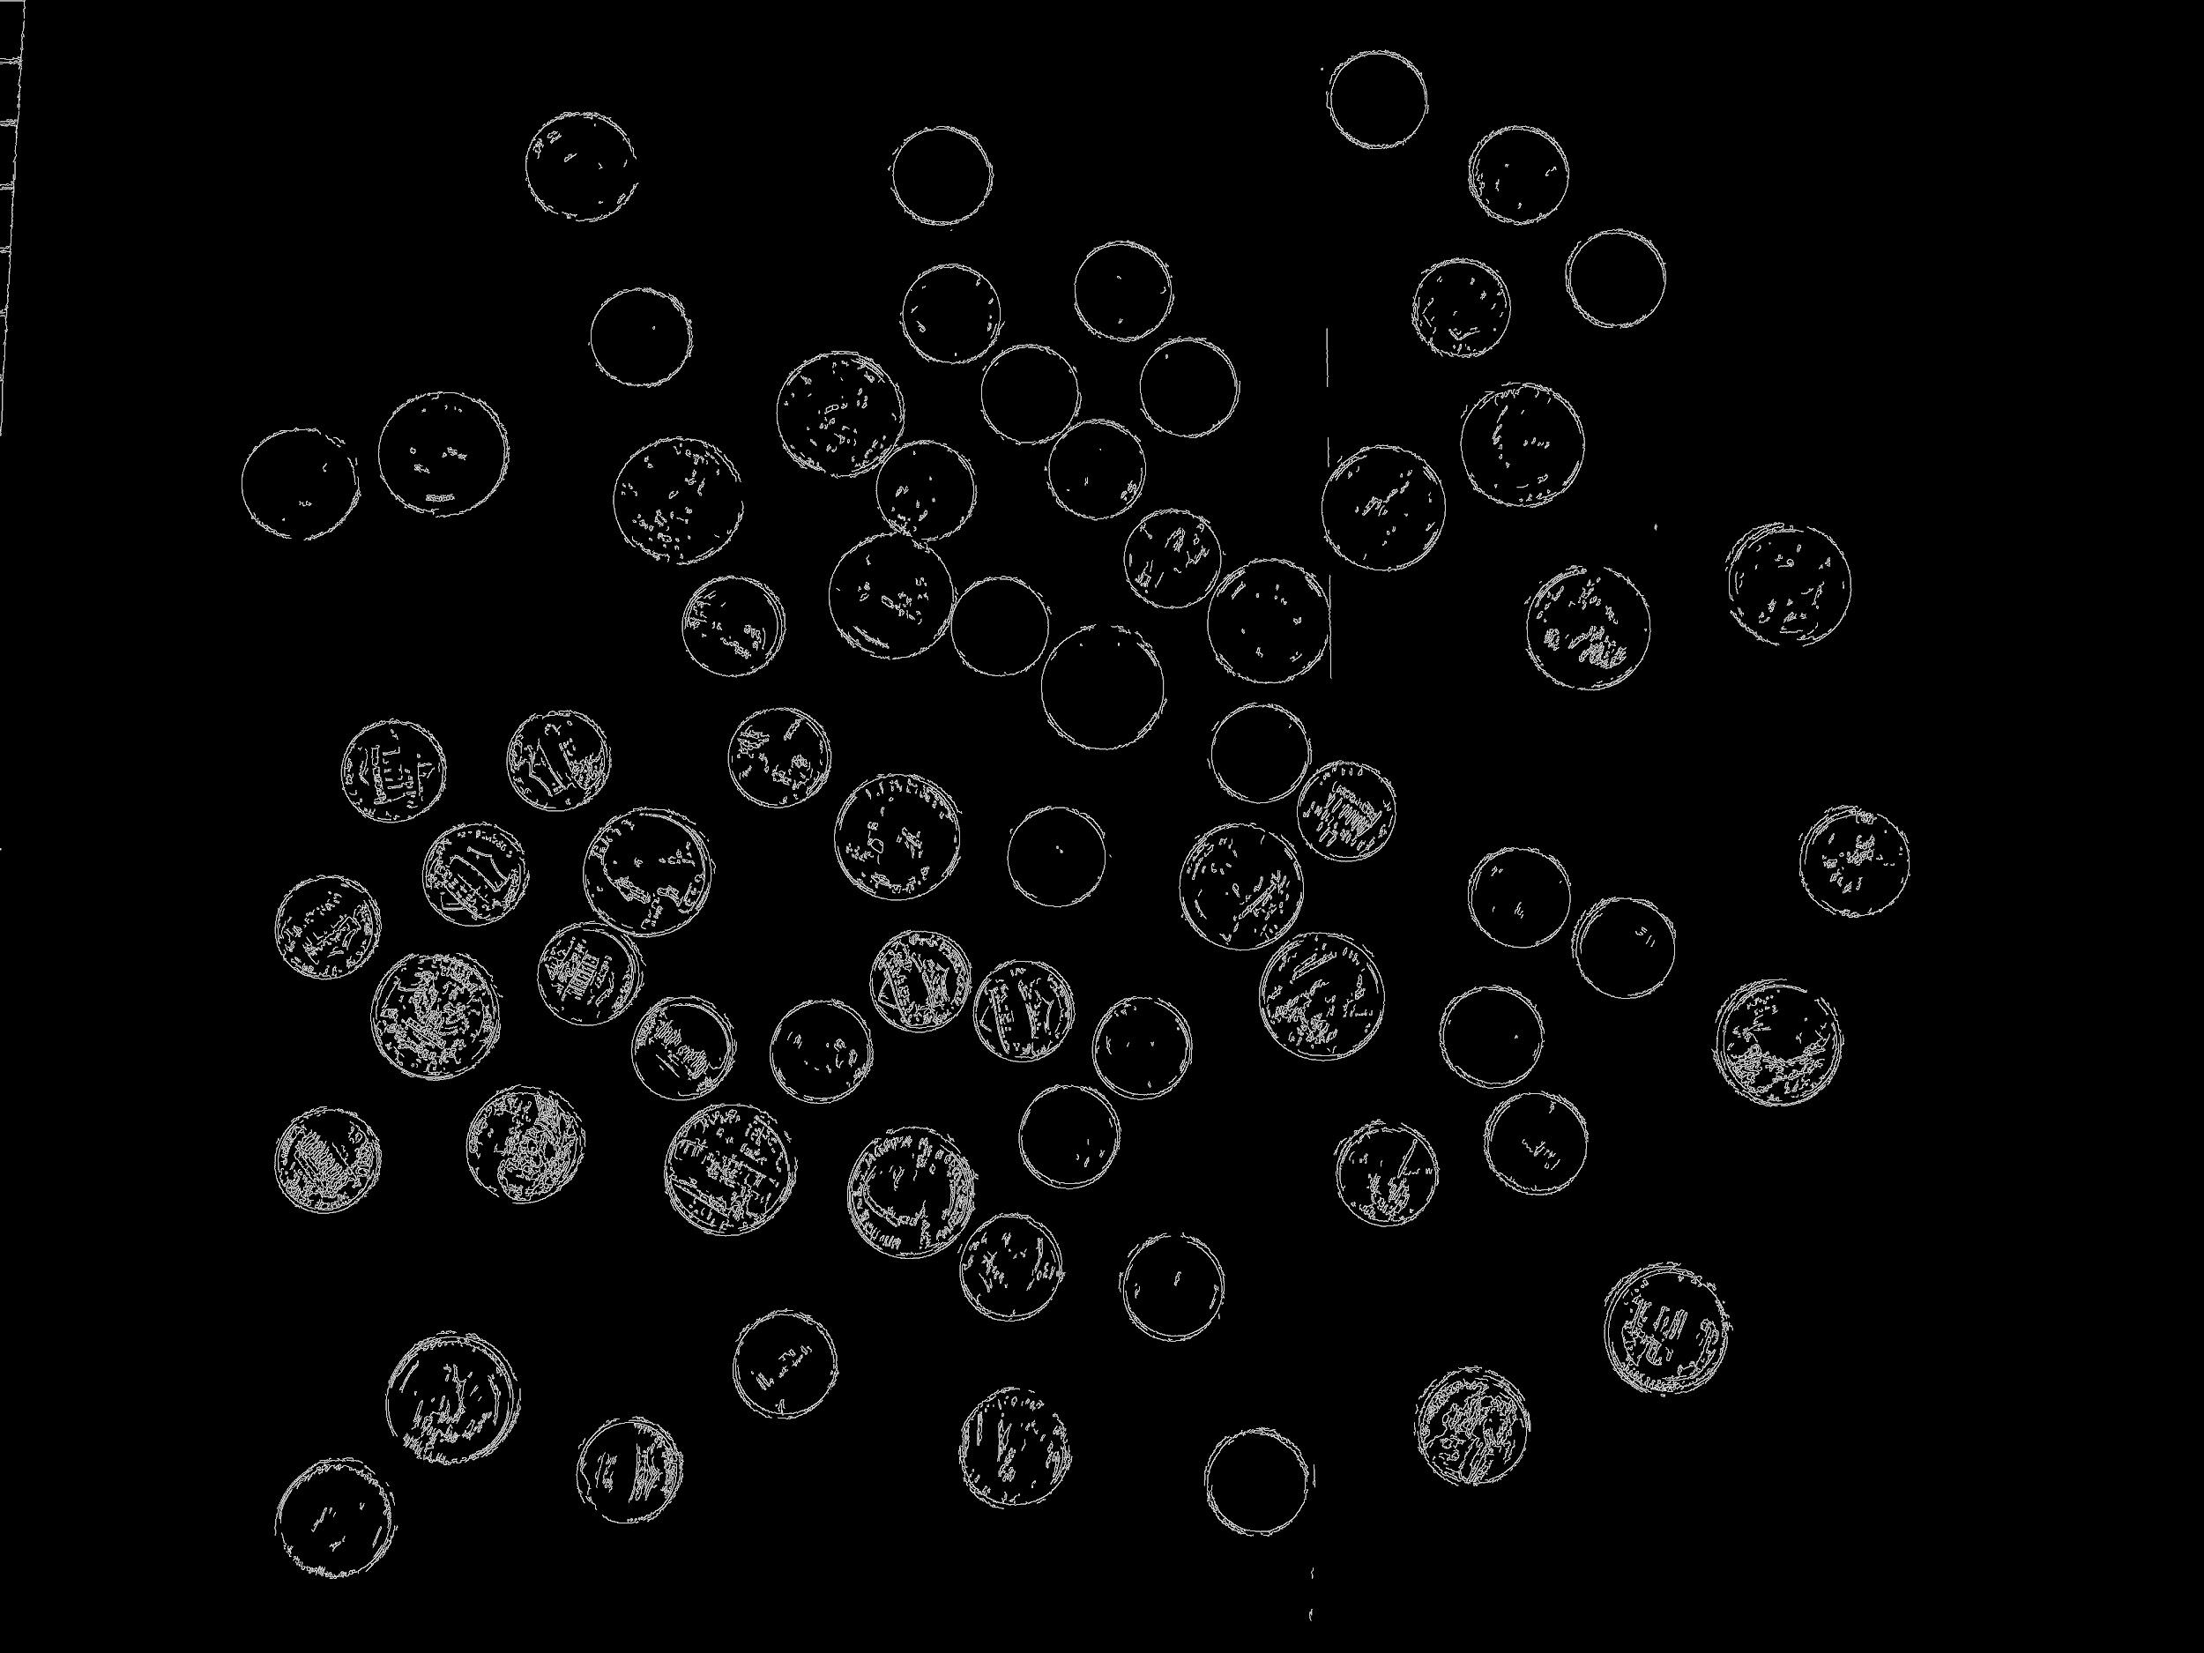

imageCircles.jpg:

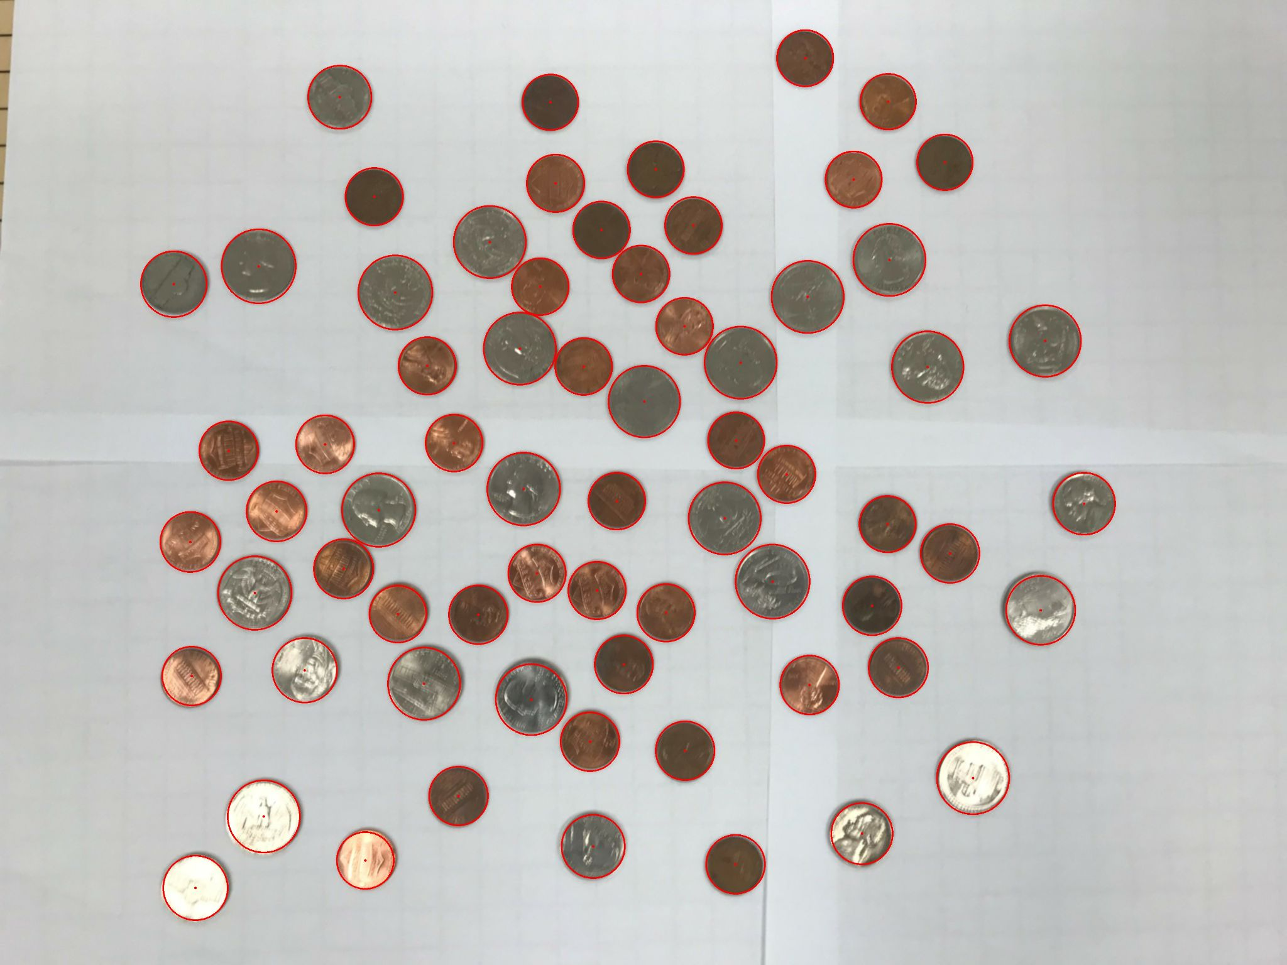

imageCoins.jpg:

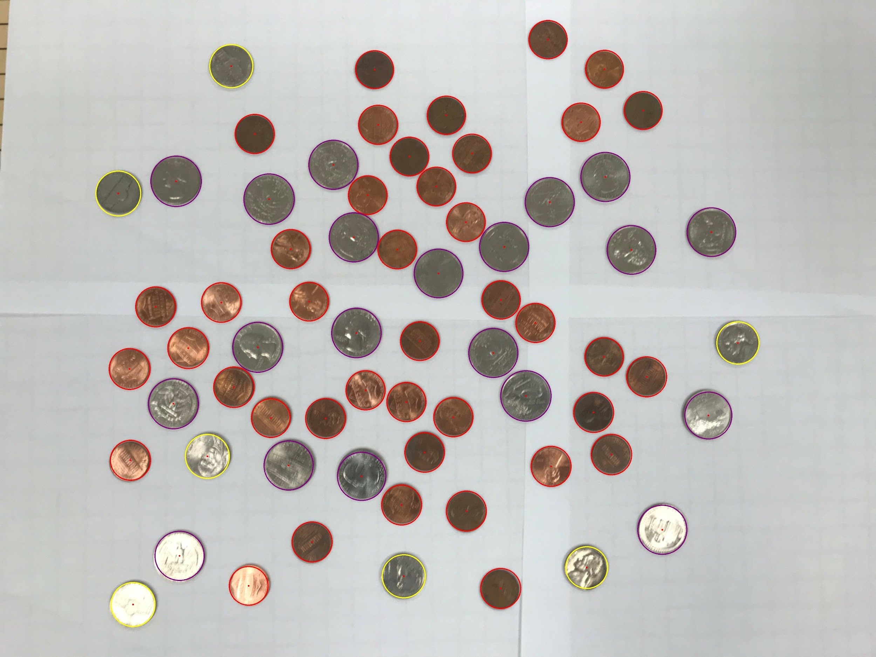

Content of results.txt:

penny - 41

nickel - 7

dime - 0

quarter - 20

half dollar - 0

dollar - 0

Total: $5.76

1. For the medium image:

Command line including all parameter values used for this image:

-f coinsHarder.jpg -ht 200 -TC 25 -mincentdist 50 -minR 80 -maxR 120 -fg medg.jpg -fCi medcircles.jpg -fCo medCoins.jpg -fR medresults.txt -ff medf.jpg

-same meaning as described above

-ff name of canny edge file (default: imagef.jpg)

Initial image:

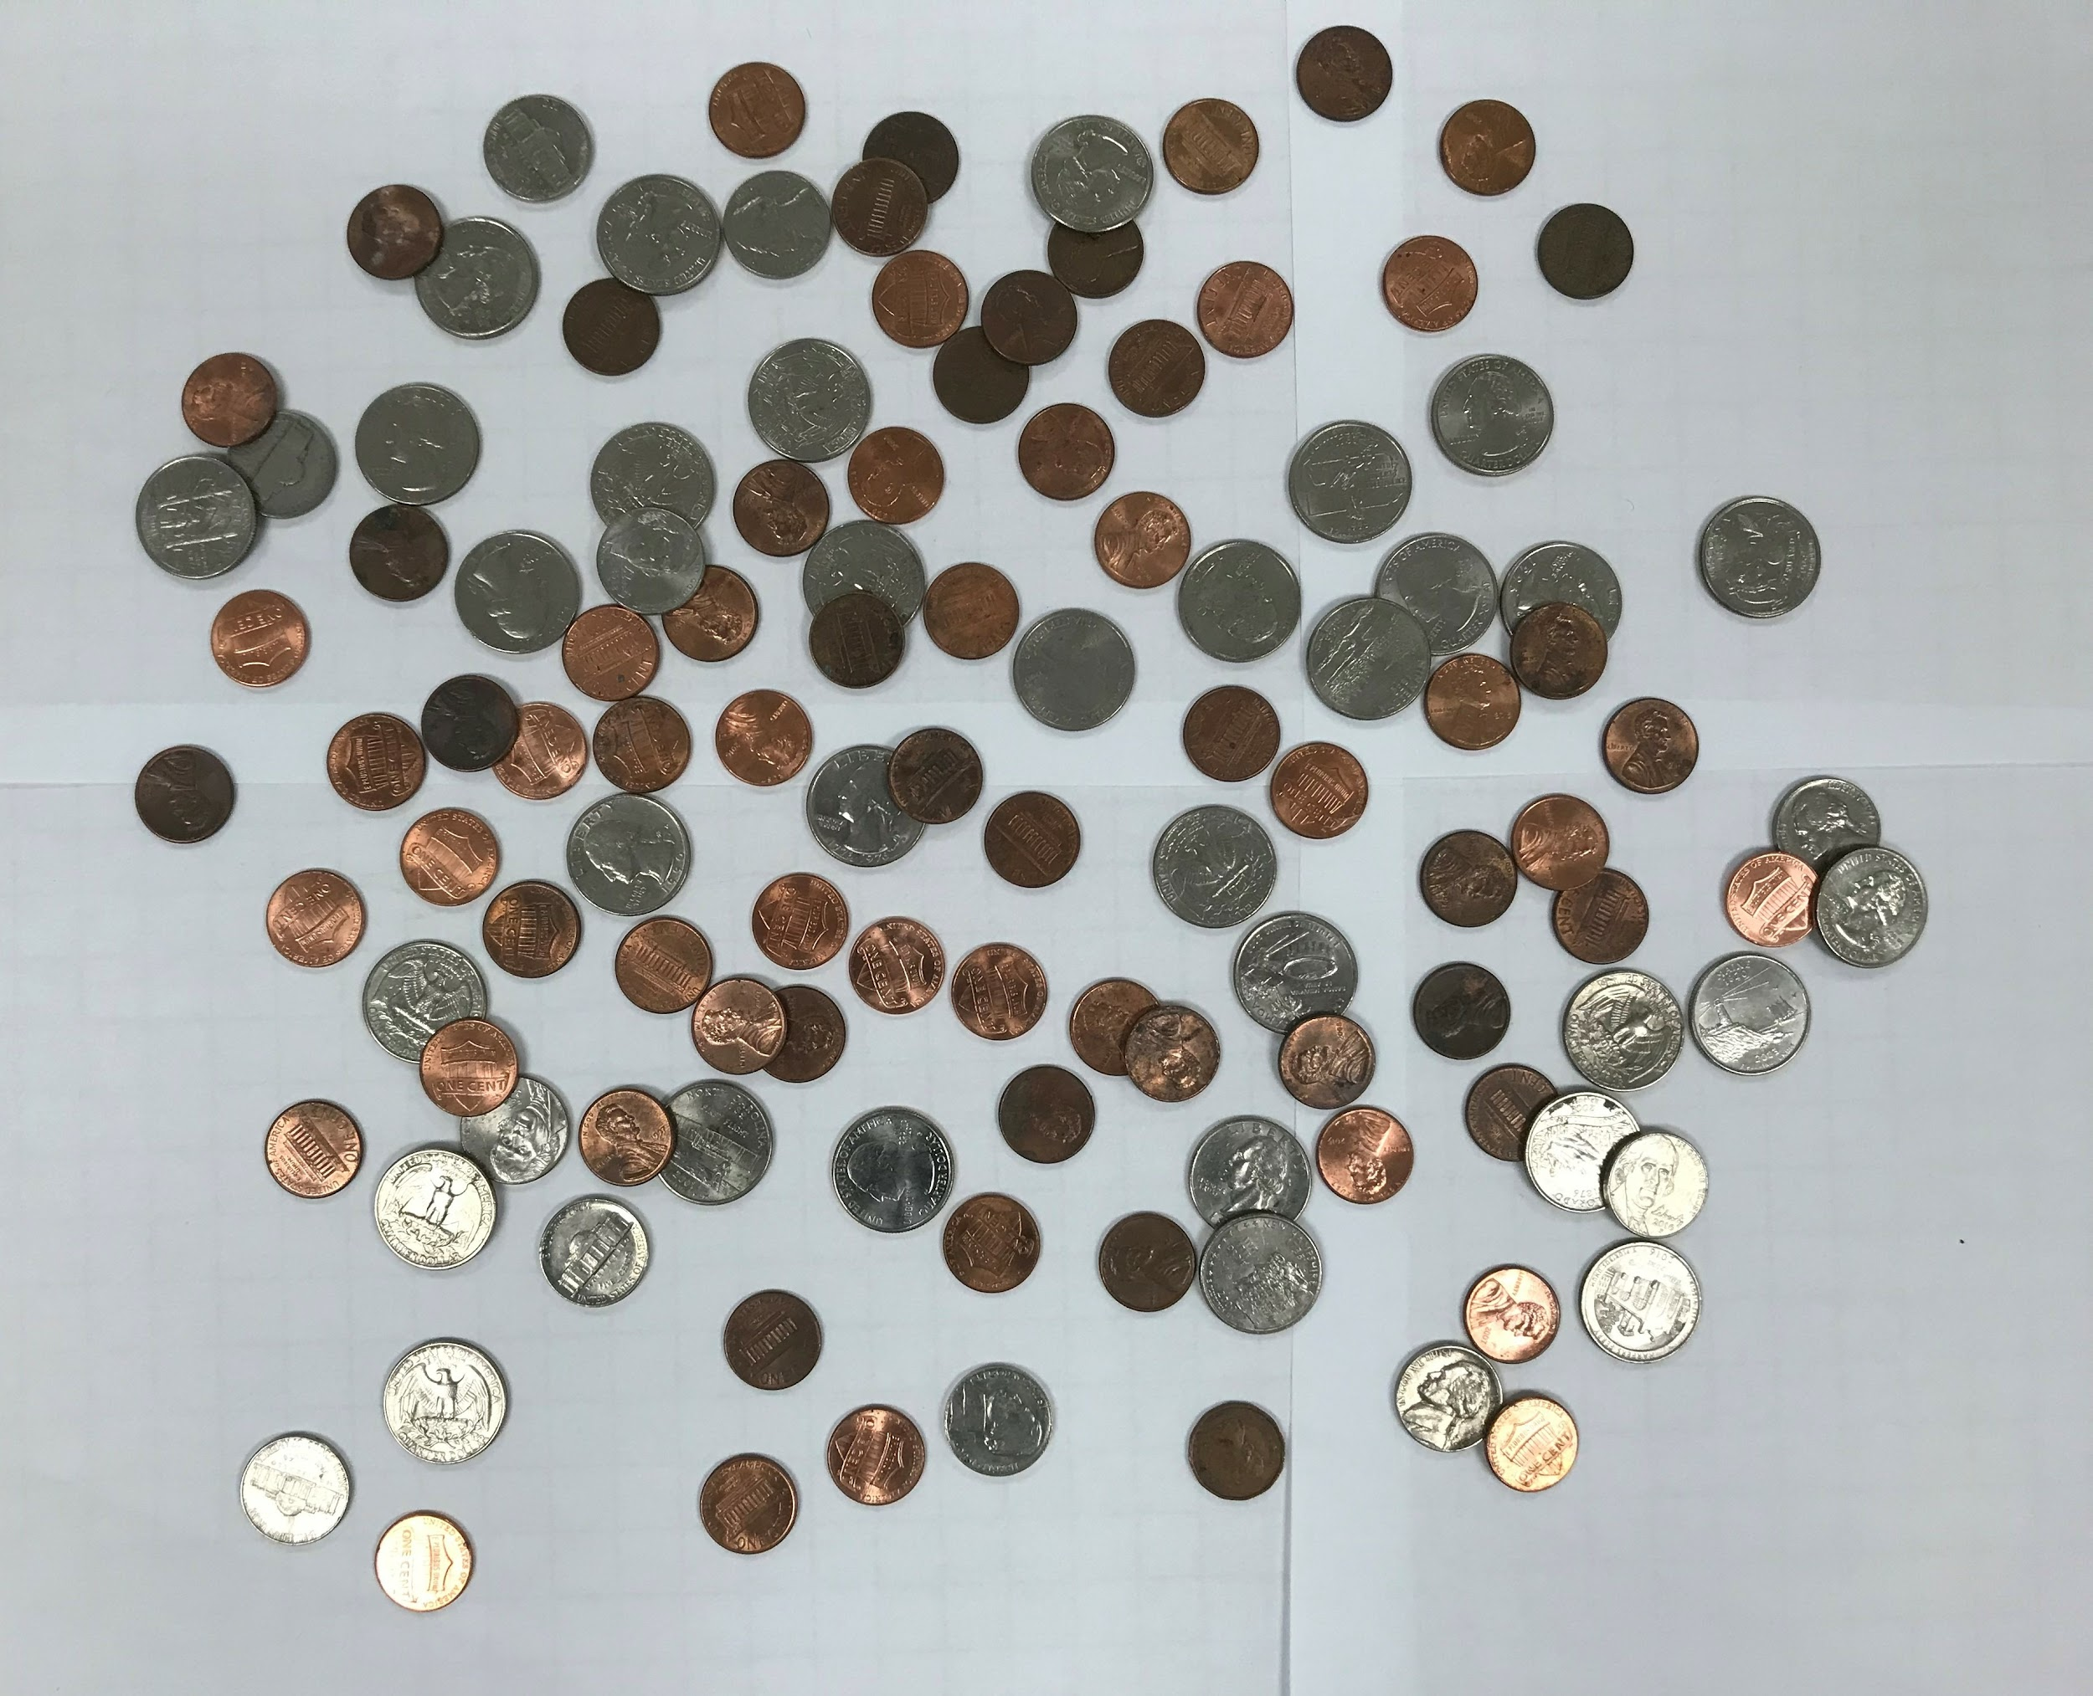

imageg.jpg:

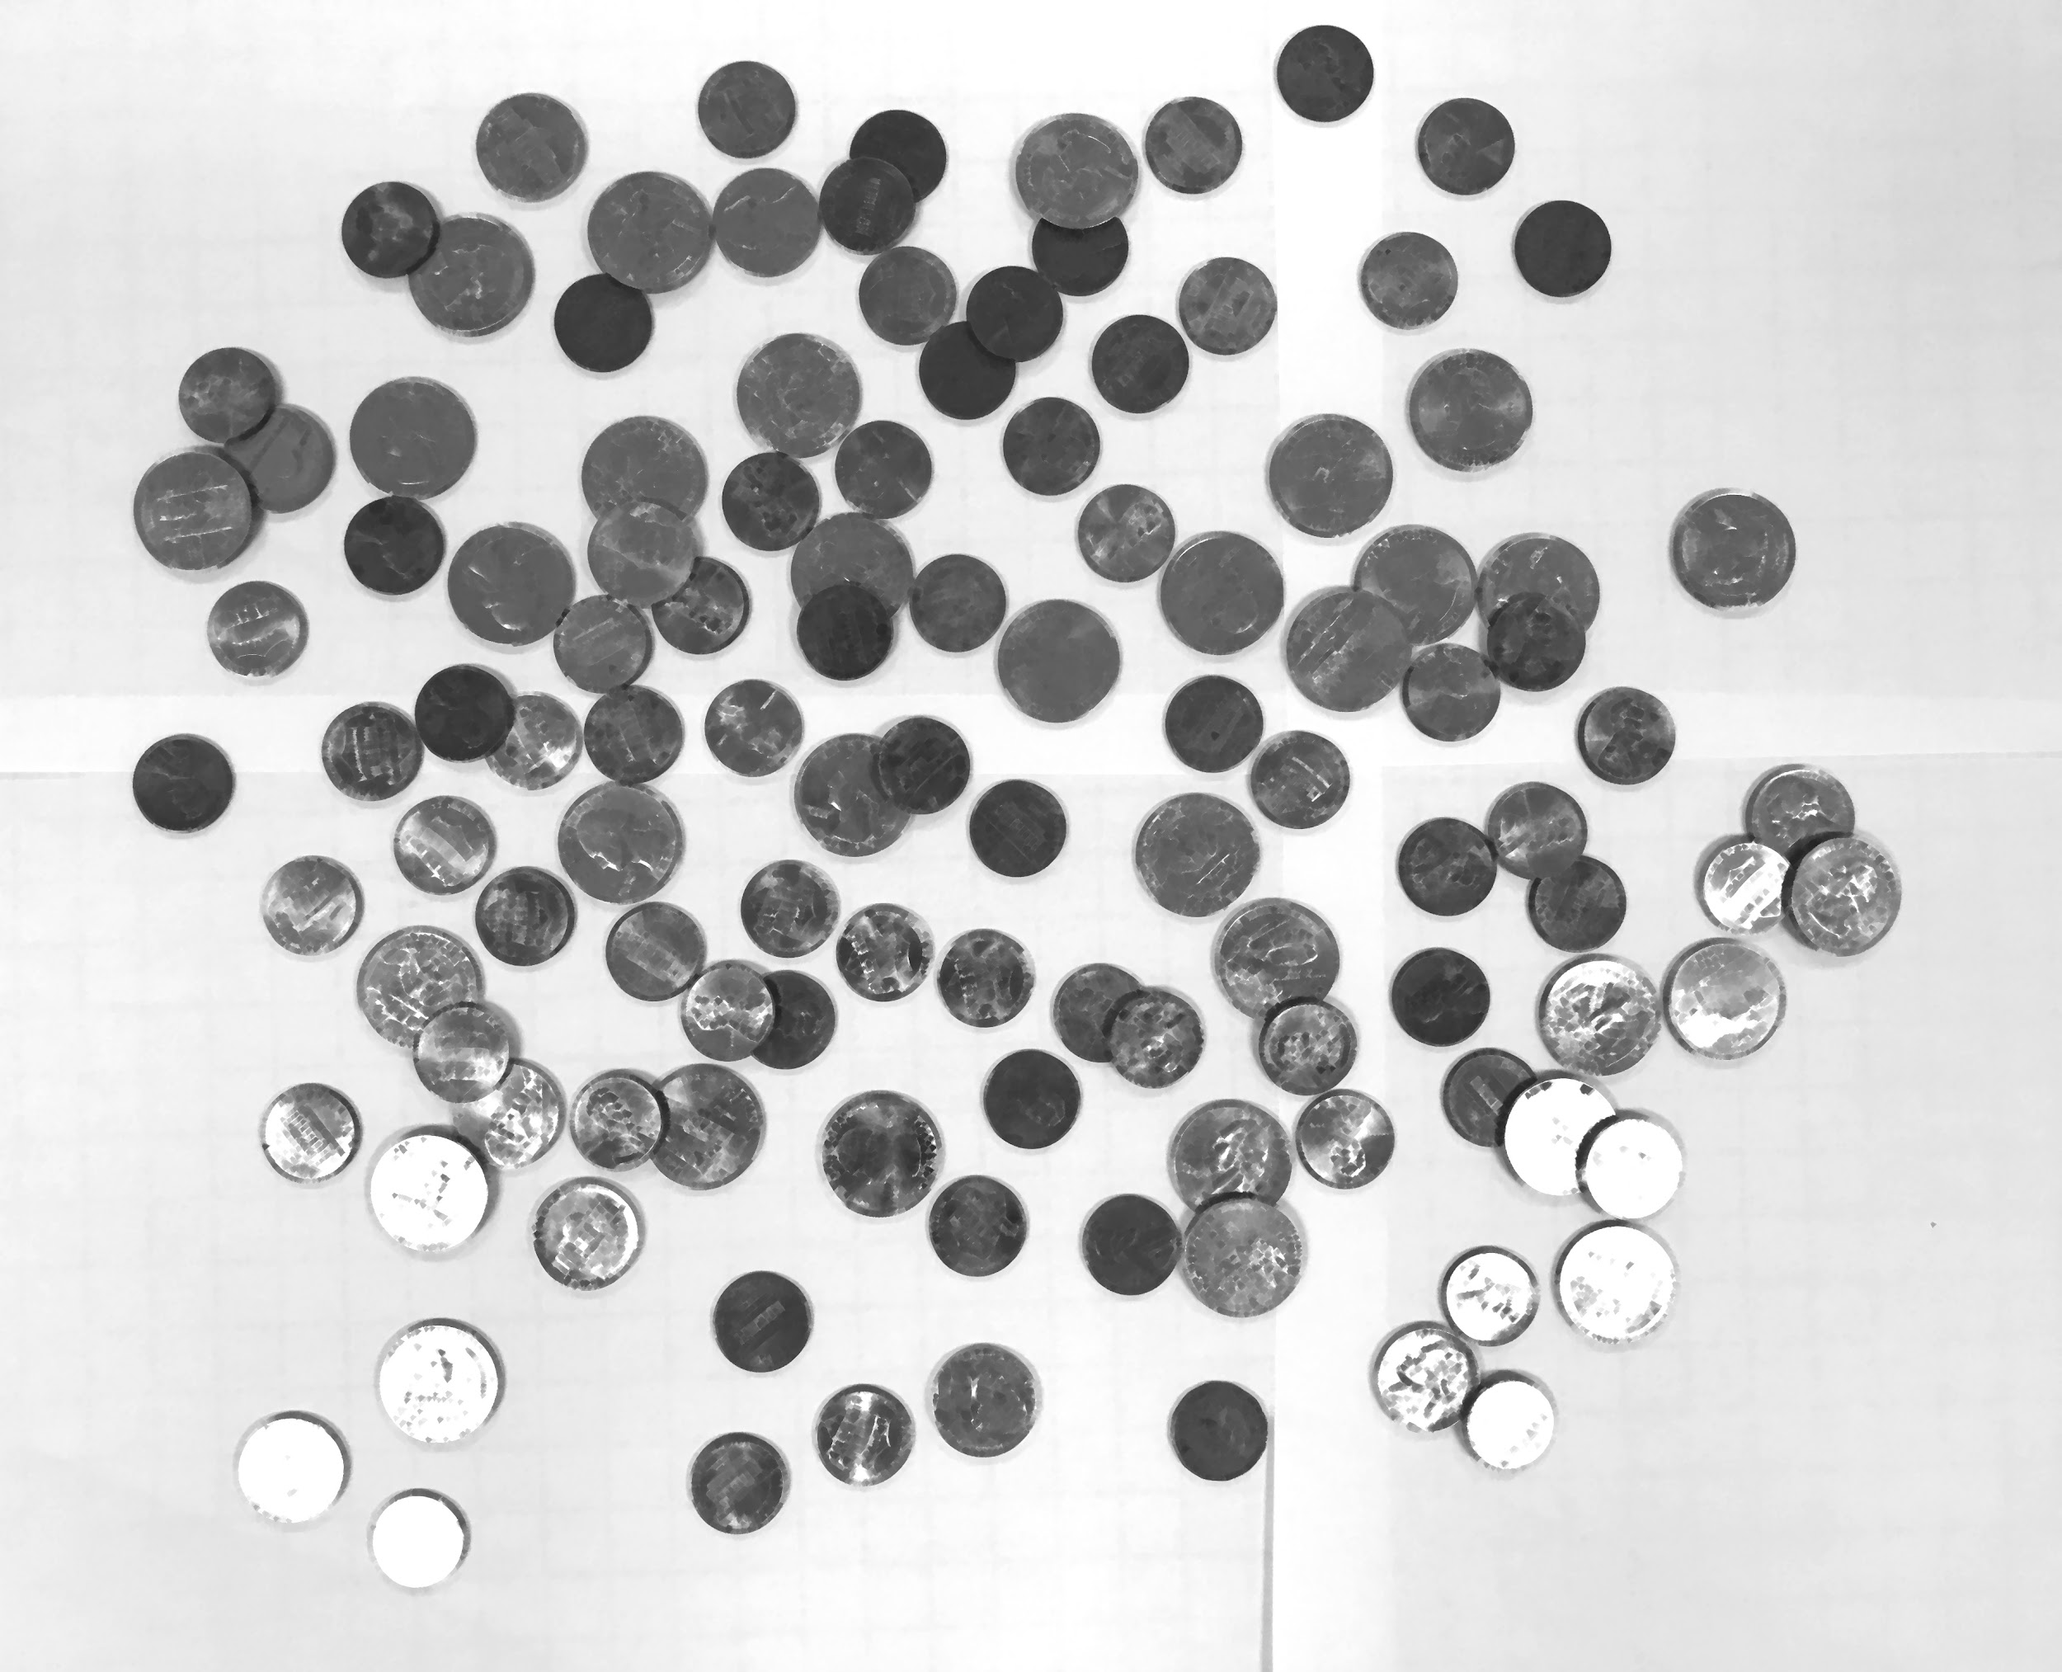

imagef.jpg

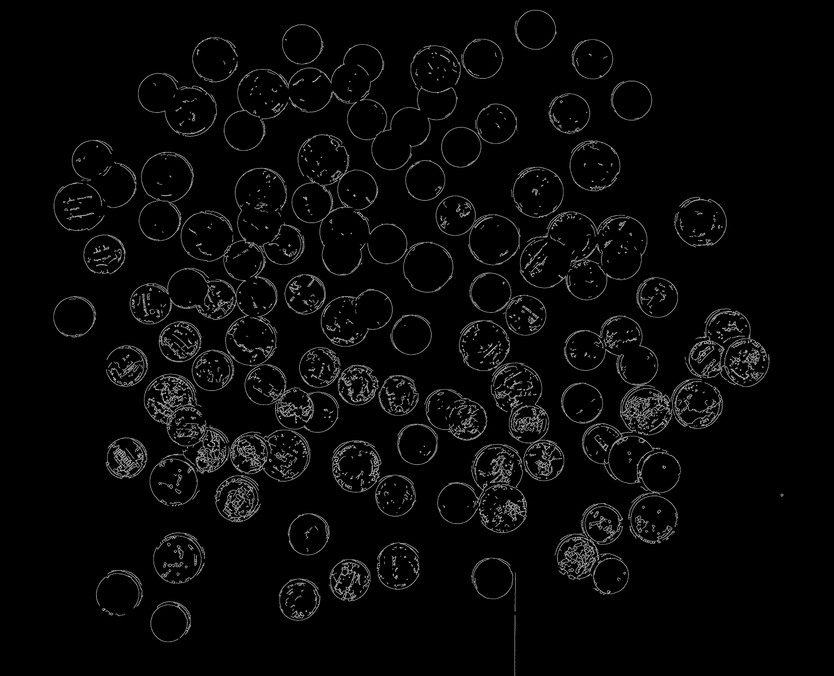

imageCircles.jpg:

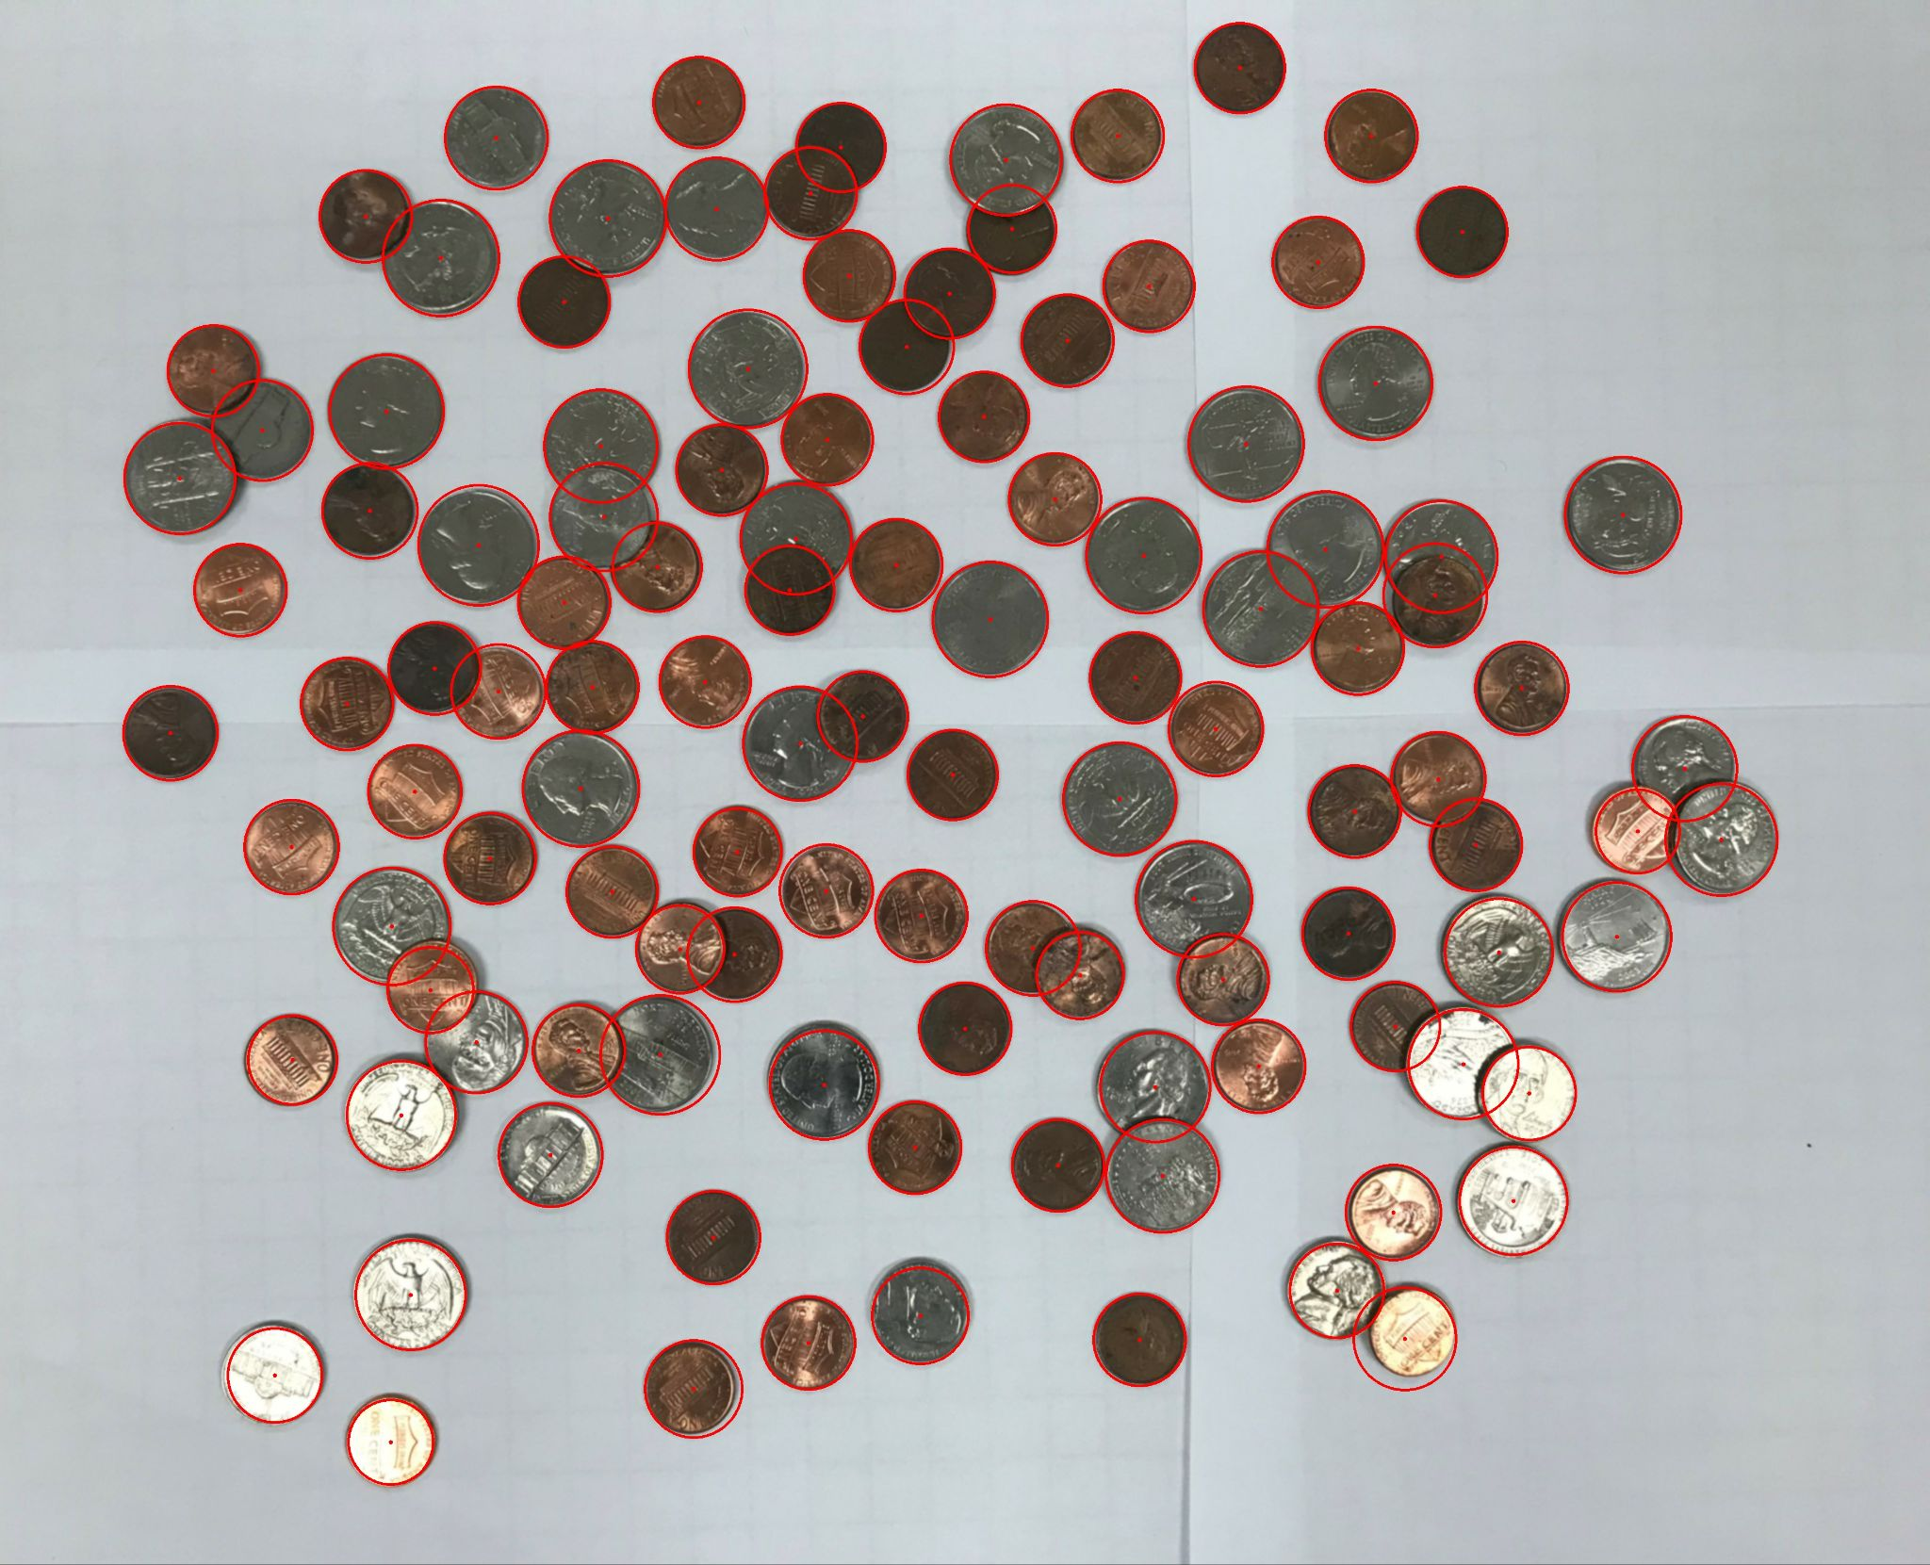

imageCoins.jpg:

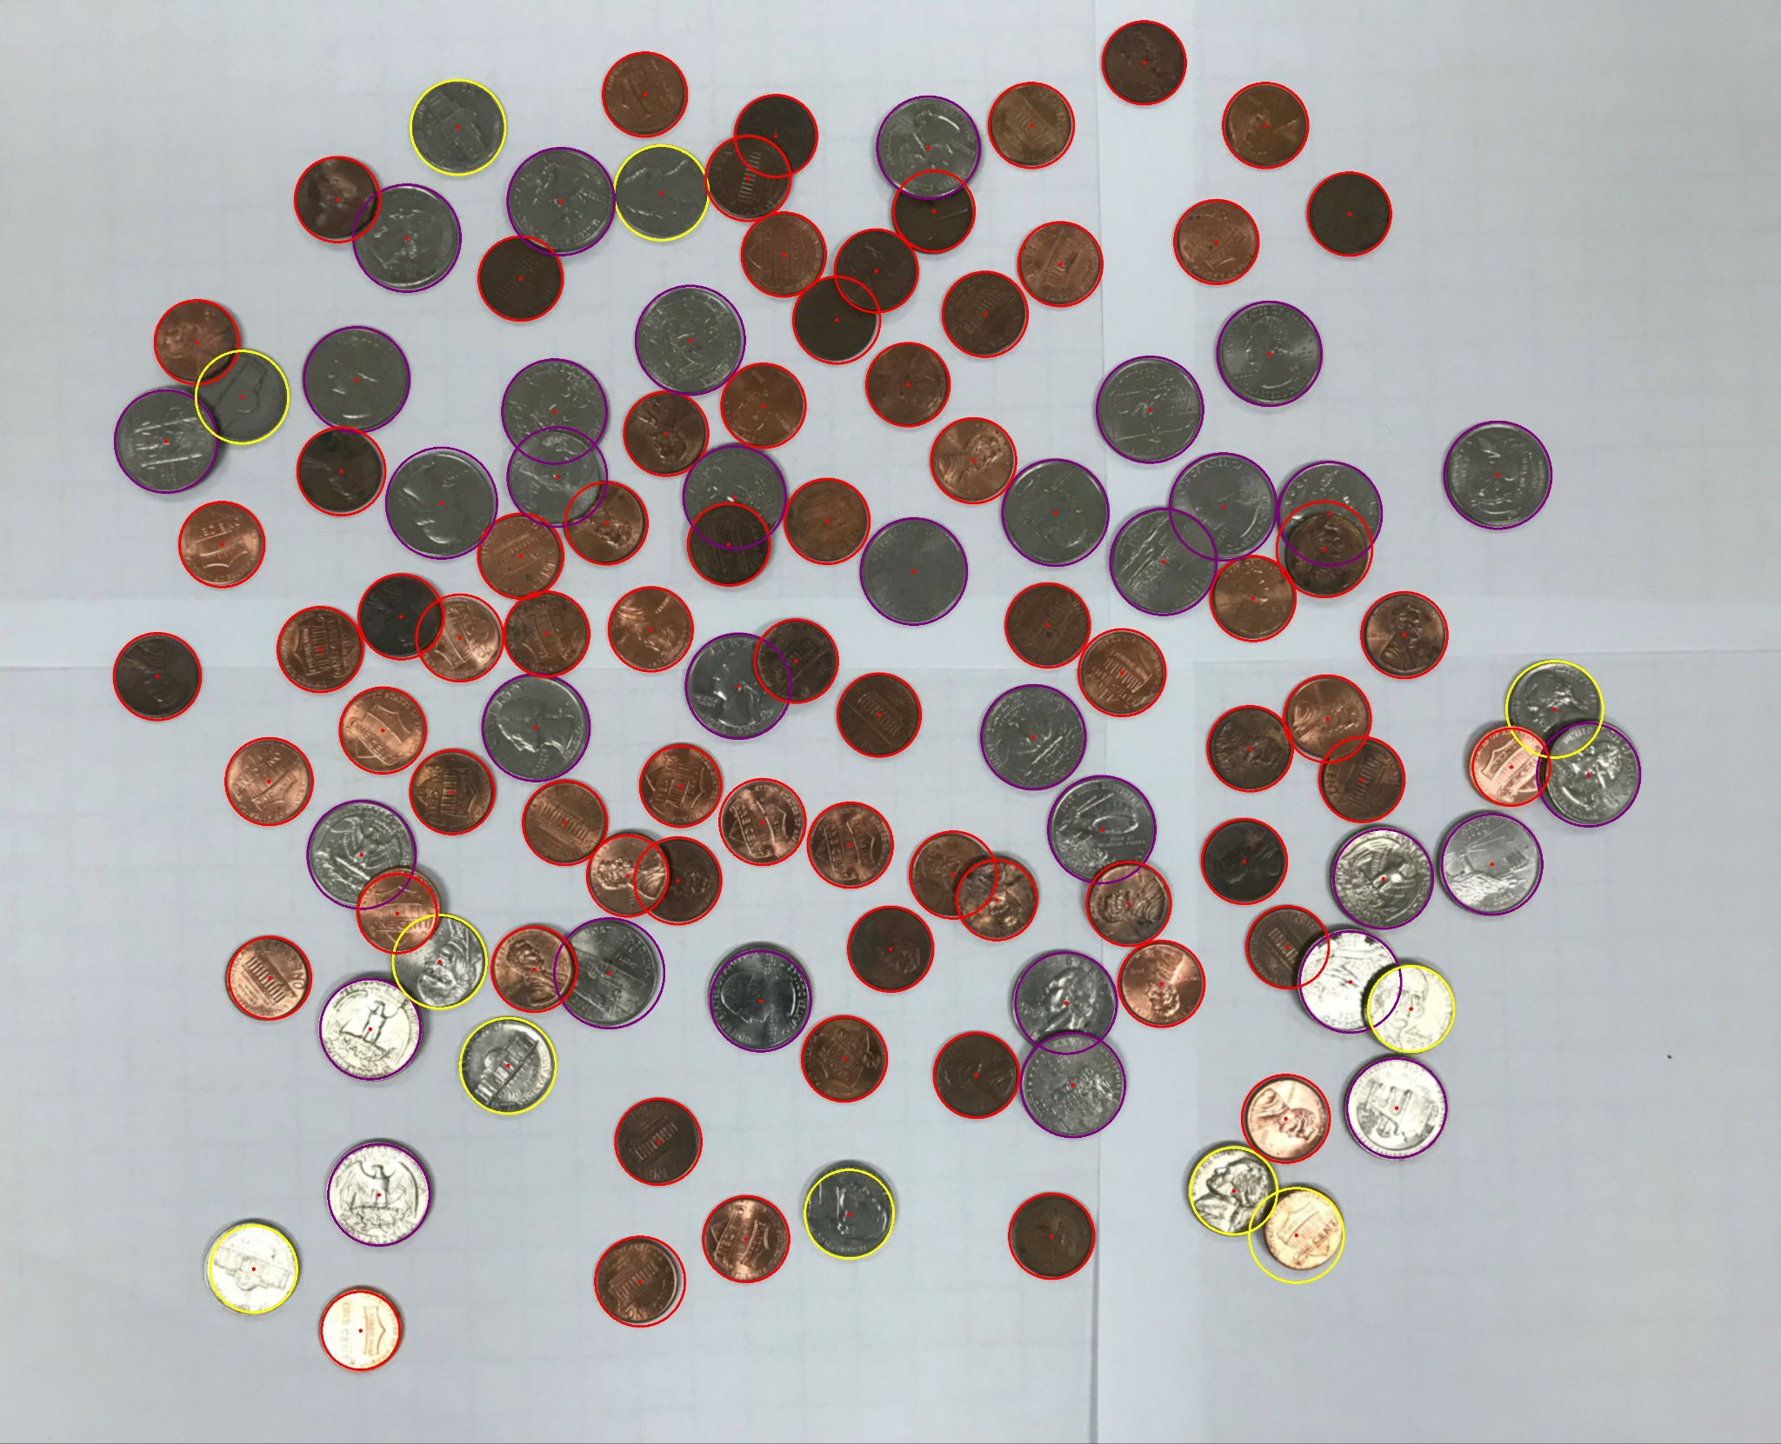

Content of results.txt:

penny - 71

nickel - 11

dime - 0

quarter - 34

half dollar - 0

dollar - 0

Total: $9.76

1. For the hard image:

Command line including all parameter values used for this image:

-f coinsHardest.jpg -ht 105 -TC 50 -hard -minR 70 -maxR 180 -mincentdist 100 -fg hardg.jpg -ff hardf.jpg -fCi hardcircles.jpg -fCo hardCoins.jpg -fR hardresults.txt

-hard no arguments, indicates that the image is a hard image

Initial image:

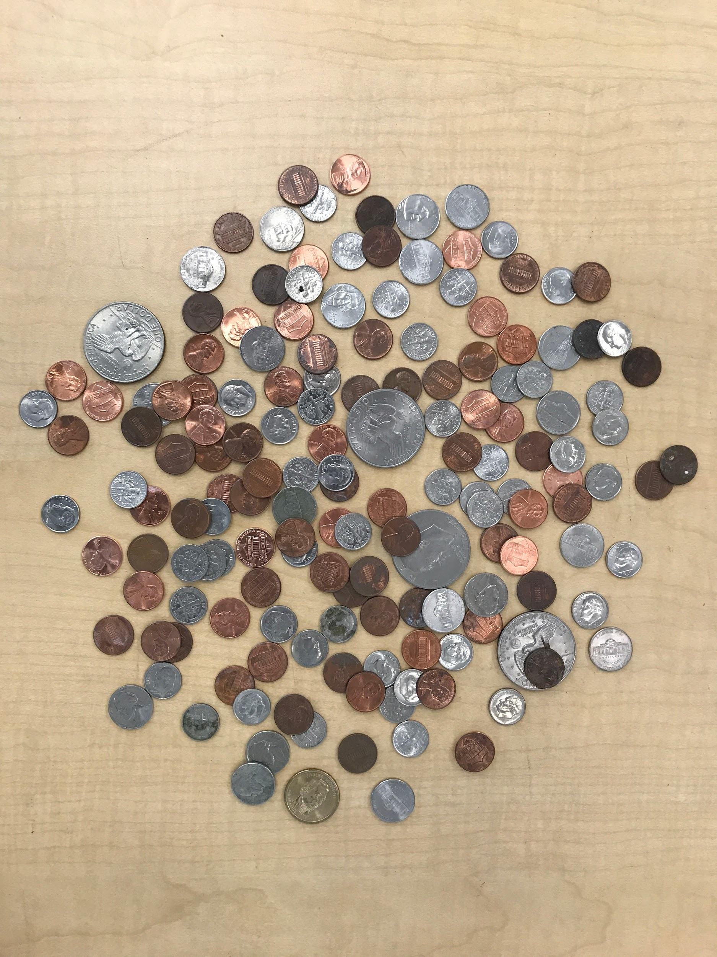

imageg.jpg:

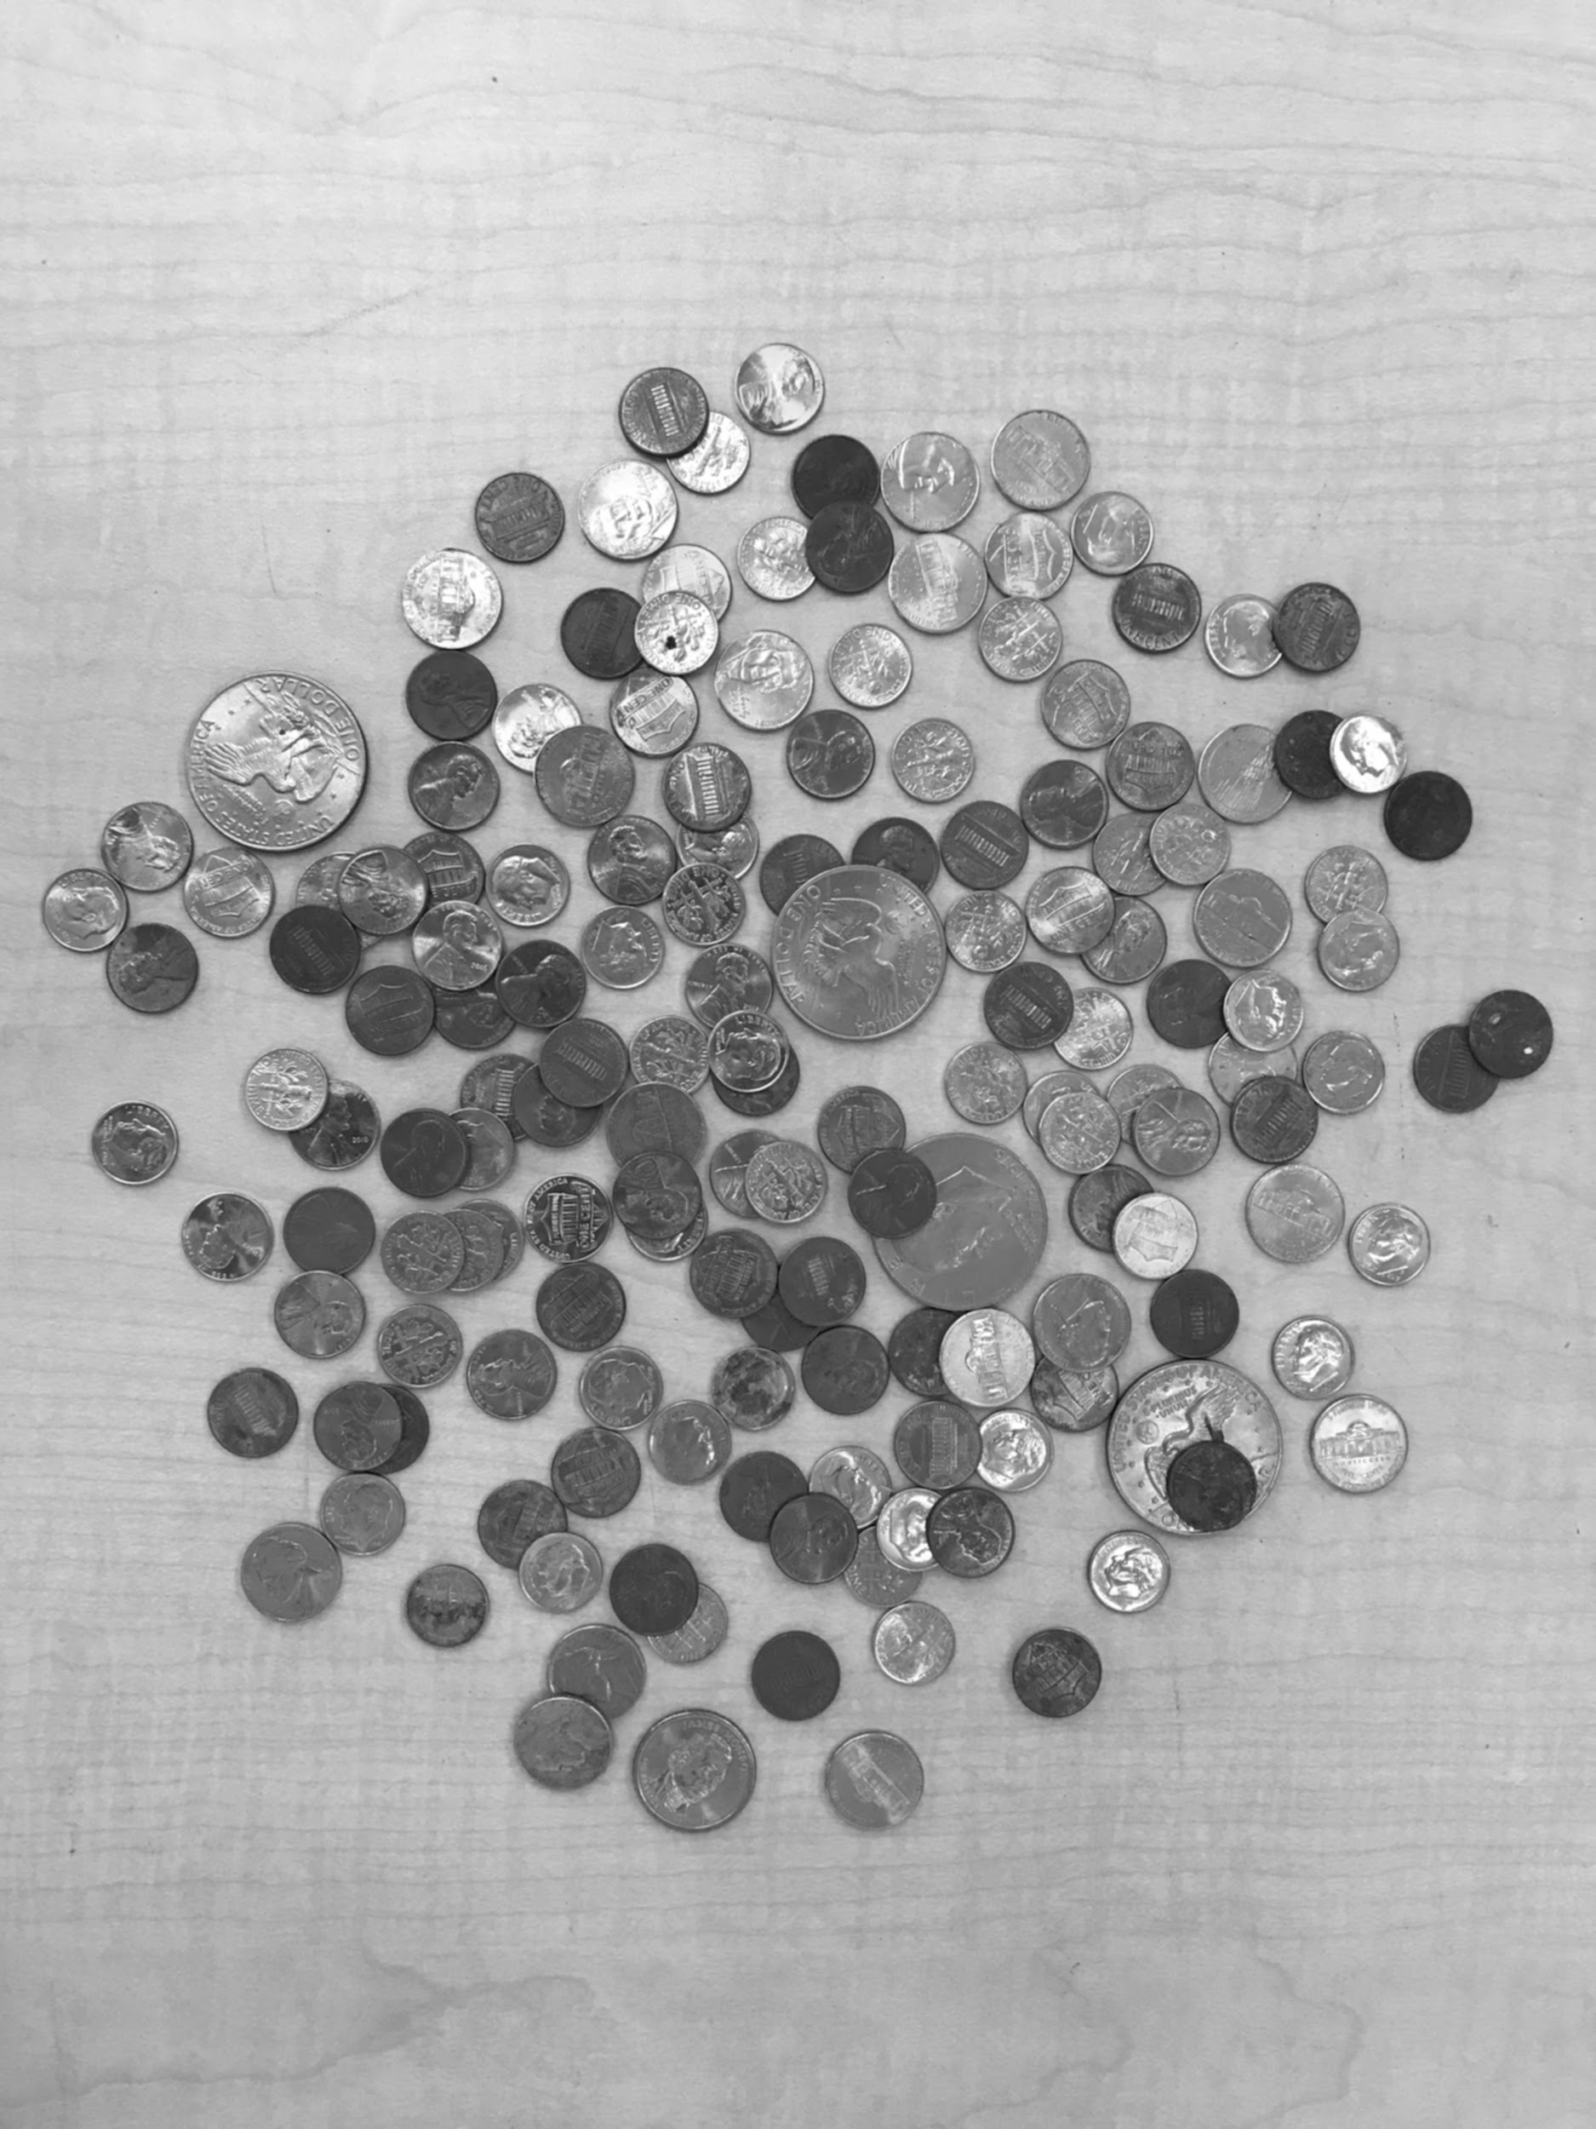

imagef.jpg

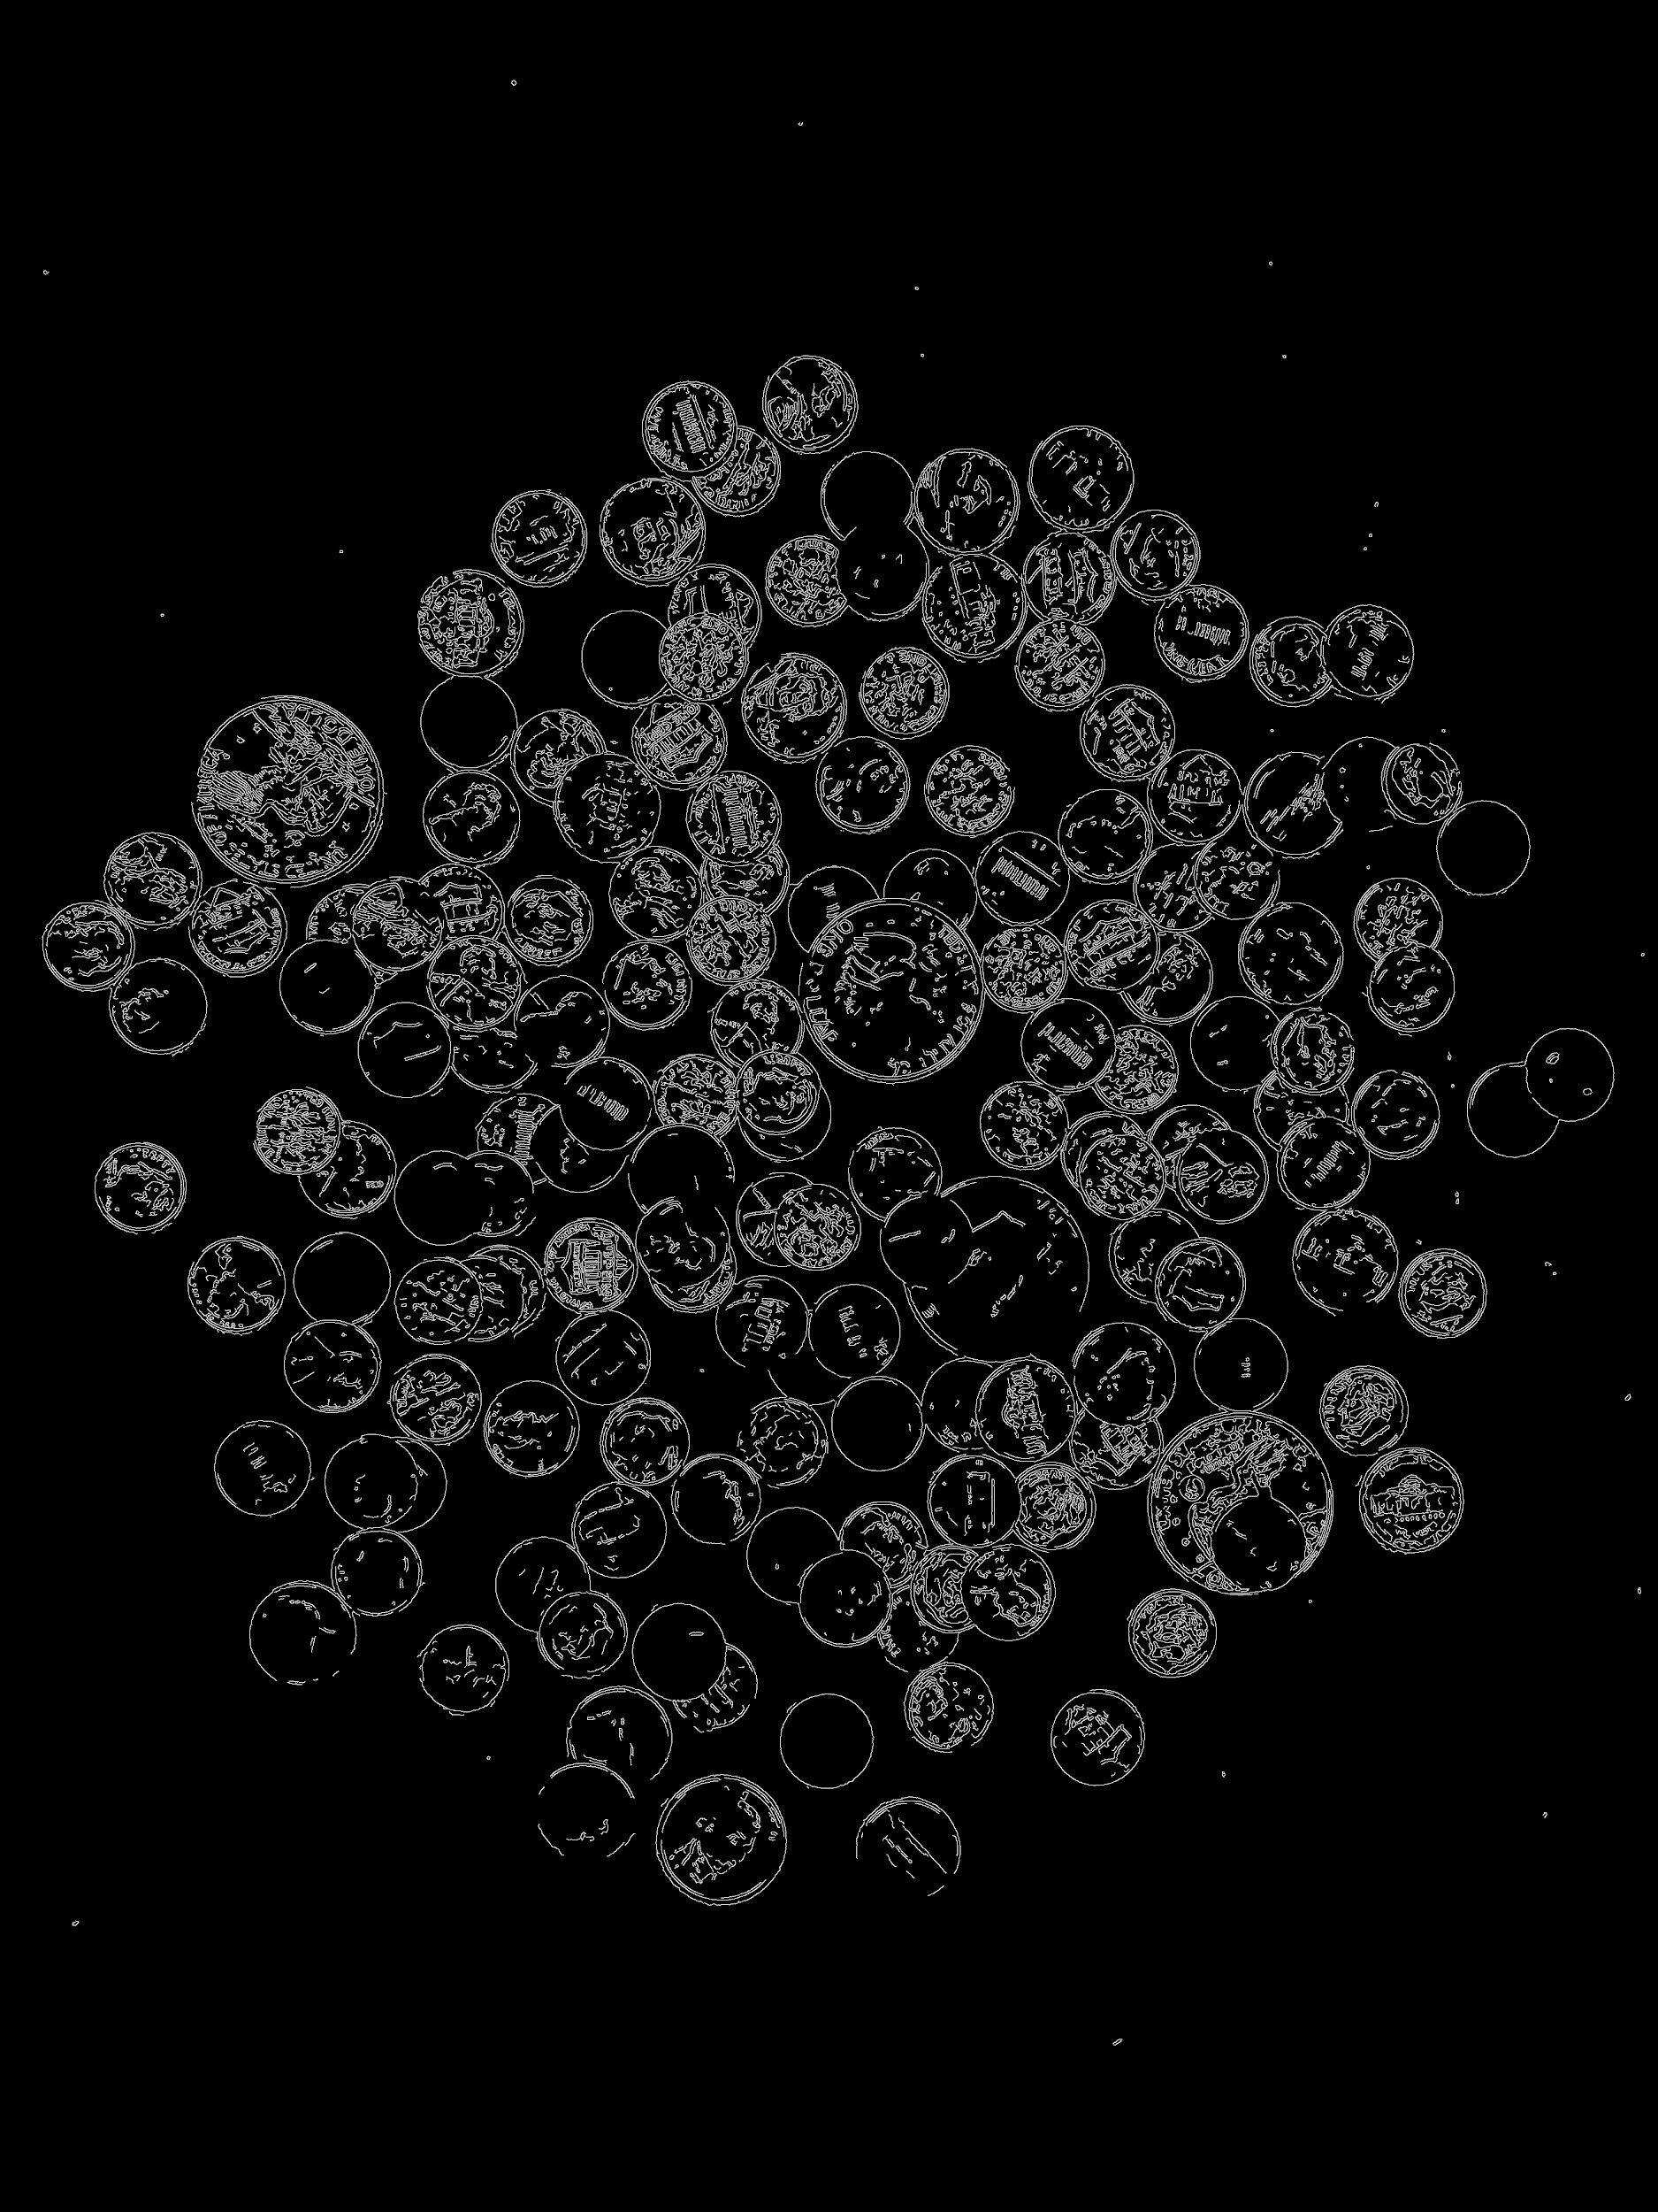

imageCircles.jpg:

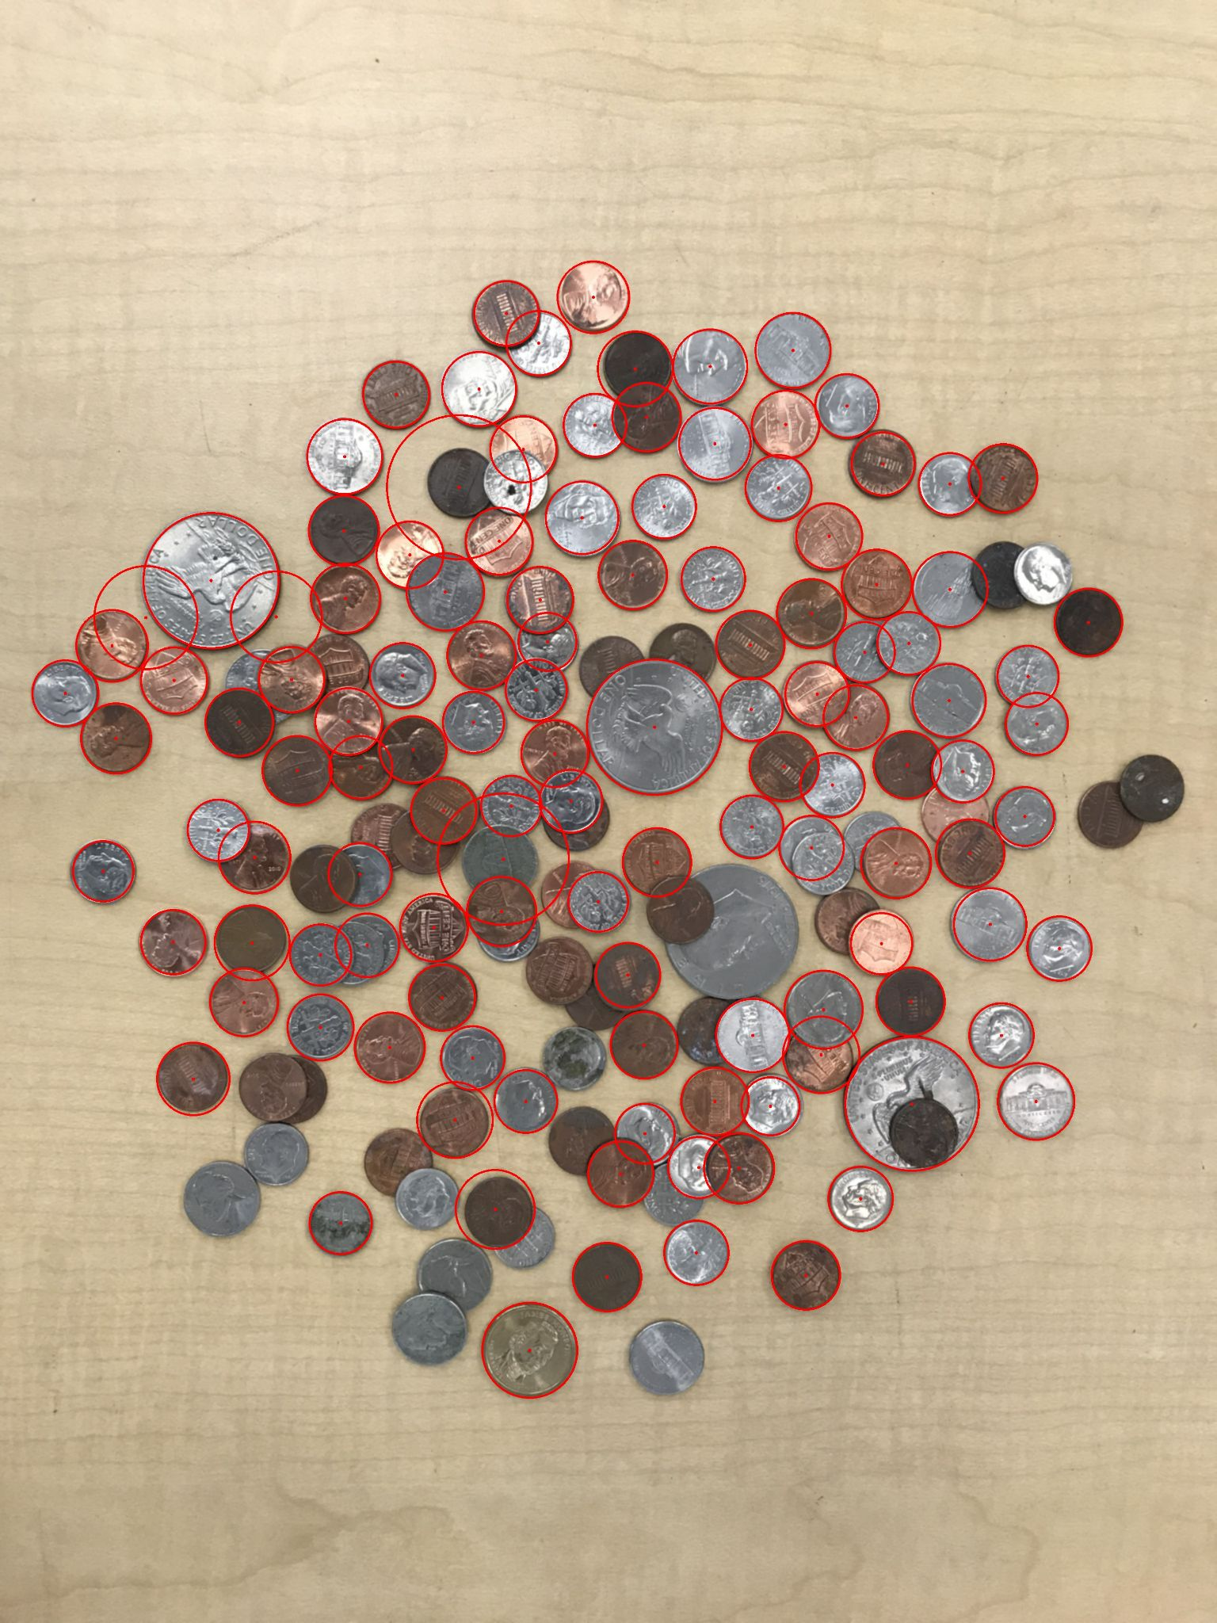

imageCoins.jpg:

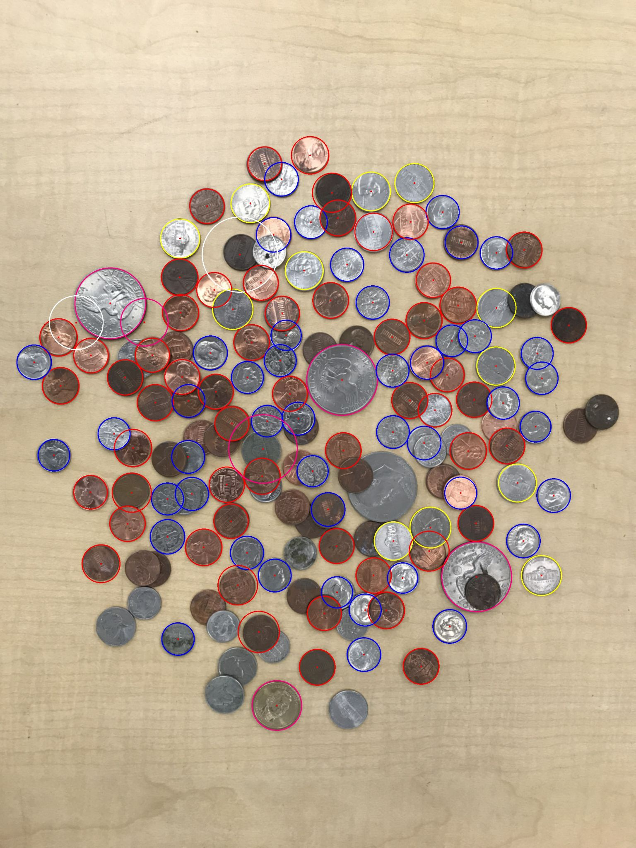

Note: white circles indicate that a coin was unable to be classified

Content of results.txt:

penny - 56

nickel - 12

dime - 46

quarter - 0

half dollar - 0

dollar - 6

Total: $11.76